PASSWORD SOFTWARE – AU PC Mtg - DEC. 17

- DASHLANE
  - Pro’s & Con’s
  - Self-learning support links
  - Dashlane virus alerts - “Threat Center”

- LASTPASS

- ROBOFORM

DASHLANE – PRO’s & CON’s
PROs
- PC Based software app – Privacy and Security
- FREE & Fee Based versions
- Requires your MASTER PASSWORD to activate & view your each web access site PW
- Allows User editing – Helpful for CUSTOM NAMES
  - Easy to edit existing app icons
- Provides many APP ICONS for quick finding – ie, Amazon, Google, Fidelity, Walgreens
  - All apps are ALPHA Sorted automatically (in a PW encrypted Vault)
- MUST OPEN WITH A PASSWORD TO ACTIVATE at START UP or AFTER CLOSING
- Reasonable learning curve
- Few usage issues
- Works well for about + 90% of apps selected
  - Some sites have security measures to prevent auto log-in
    - Examples are banks & financial institutions (constantly changing)
- Dashlane customer privacy / password violation notices – see exhibit
- Allows for Web Form info storage (name, address, credit card, web purchase receipts)

CONs
- Learning Curve
- Some Applications may not accept auto log-in or create difficulty to work easily
  - How to determine “what’s wrong” – “why won’t it work?”
- Customer support – EMAIL ONLY / Non – premium ( $ 29.95) customers wait longer than paying customers

DASHLANE – Provides SELF-LEARN Support Links
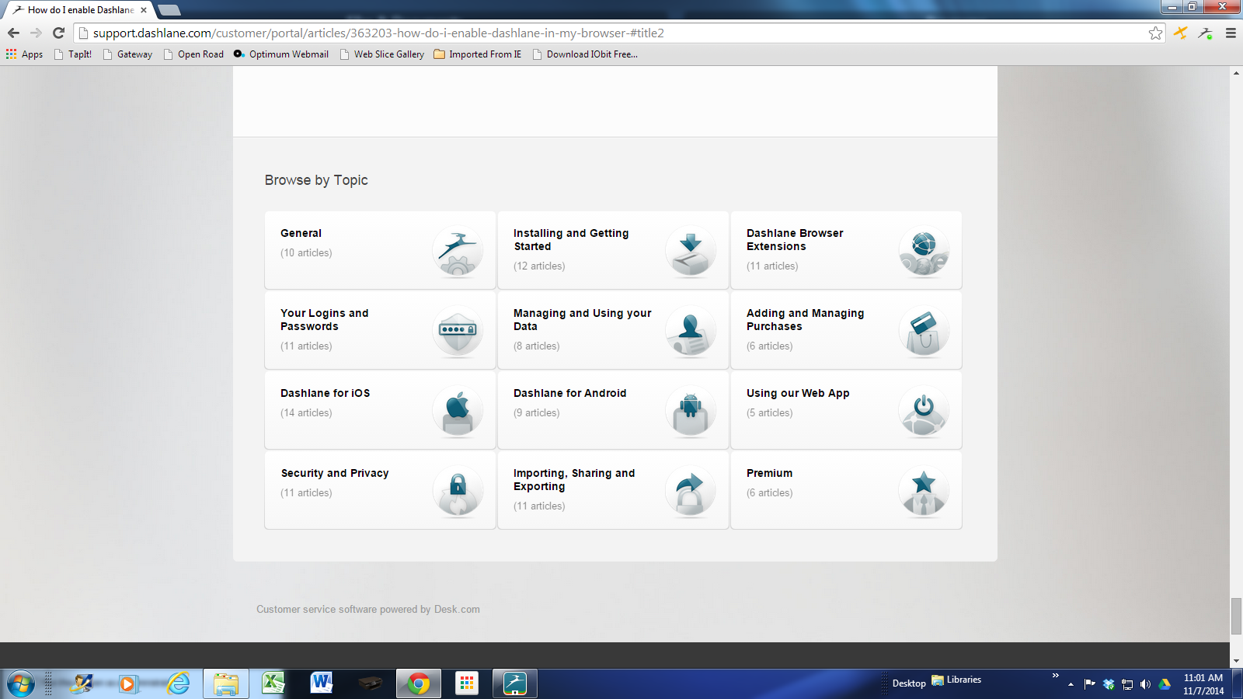

DASHLANE Link – LOGINs & PASSWORDS
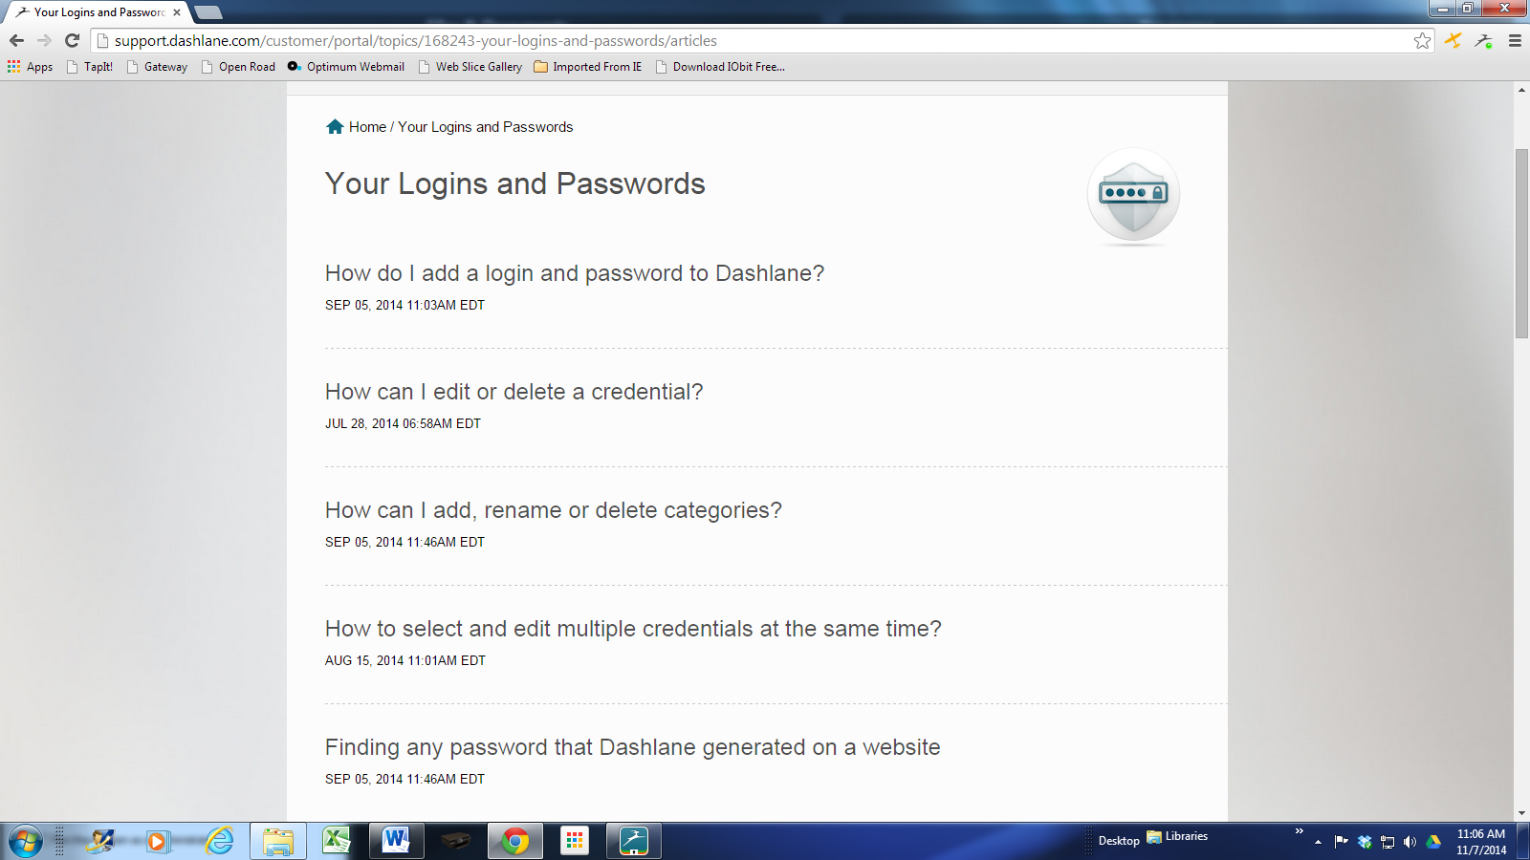

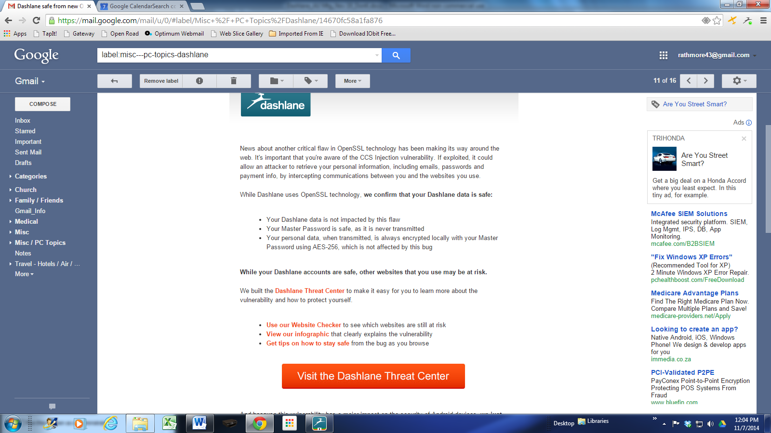

DASHLANE – Password Manager
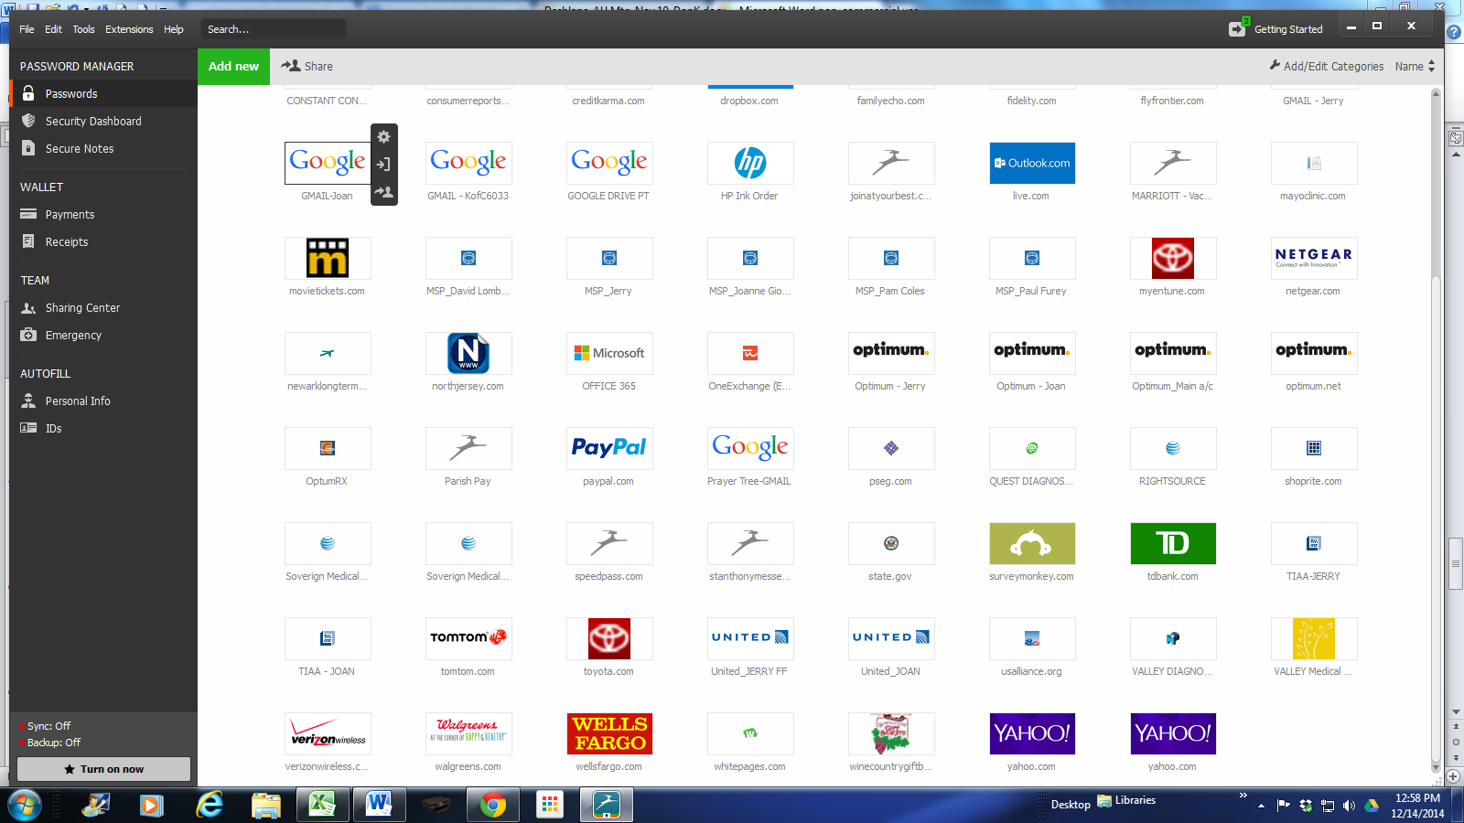
OTHER PASSWORD SOFTWARE CHOICES
LASTPASS
- Very strong – Top 3 competitor (features, platforms, support – email)
- FREE version – (premium is $ 12 per yr / adds smart phone sync + priority email support)
- Lastpass is a cloud based application using encrypted software at your pc before passing passwords to company servers for storage.
- Unlimited logins
- Auto generates passwords

ROBOFORM FREE (Entry Level)
- Limit is 10 logins or less. (not recommended)
  - Next version is unlimited logins @ cost of $ 9.95 1st year. . ROBOFORM EVERYWHERE
- Will generate passwords for owner
- Ease of Use – varies by site and user experience
  - May not support all websites
- Customer support available by phone (others only email)
- Provides access across multiple platforms
  - Synchronizes PW management across browsers and mobile devices
  - Stops working if you let subscription lapse
  - Very strong – Top 3 competitor (features, platforms, support – best)

